**Team: LinTech Solutions**

**Members:** Canarias, Mandap, Sanchez (D.)

**Overview:**

Badminton is a highly popular sport in the Philippines, as seen by the many players participating in both competitive and social contexts (Yap, RAA). The University Athletic Association of the Philippines (UAAP) has included the sport, reflecting its widespread appeal in the country and demonstrating significant institutional support (Guilas et al., 2006). Nonetheless, aficionados in this sports field have logistical challenges, especially regarding procuring specific gear and clothing. Interestingly, traditional stores usually provide very little badminton-specific stuff, so customers must make do with an assortment of general athletic goods.

Digital marketplaces have flourished, offering a wide range of goods. These platforms seldom adjust their content to meet the specific needs of badminton enthusiasts, which limits access to products that are essential to the game's recreational and competitive practice (Bueza et al., 2023). This gap motivates a focused e-commerce platform. This virtual channel would provide easy access to a variety of high-quality badminton gear and function as a virtual agora for fans to share knowledge, ask for guidance, and stay up to date on the most recent advancements in the industry (Zhang et al., 2023).

In this context, our study aims to develop a customized mobile e-commerce application that appeals to the preferences of the Filipino badminton community. By integrating a carefully selected selection of merchandise tailored to a particular sport and an engaging community platform, this digital solution seeks to replace the shortcomings of traditional stores and general Internet marketplaces, improving the badminton community's shopping experience (Cruz, AB, 2022).

**Problem Statement:**

The latest research highlights the benefits of using specialized mobile shopping apps, emphasizing the need for a dedicated badminton e-commerce mobile application. While general sports e-commerce platforms are available, they often lack focus on individual sports like badminton, resulting in a less satisfactory shopping experience for badminton players, clubs, and coaches. Conversely, a specific e-commerce platform for badminton would offer a tailored shopping interface exclusively for badminton equipment, attire, and accessories. This specialized application would greatly simplify and enhance the shopping process by creating a dedicated community and providing detailed data and insights from user-generated reviews and ratings. Our solution aims to address the lack of specific badminton e-commerce applications, improving the digital shopping experience for the global badminton community.

**Application Analysis:**

**Proposed Application:** AeroSports

**Description:** AeroSports is a dedicated mobile e-commerce application developed by Team LinTech Solutions. The application is designed to cater to the specific needs of badminton enthusiasts in the Philippines. It aims to provide a comprehensive platform where users can browse, review, and purchase high-quality badminton equipment and apparel, as well as engage with a community of fellow players and coaches.

**Necessity of an Interface/System:**

* **Specialization:** A platform focused solely on badminton can offer a curated selection of products, ensuring quality and relevance.
* **Convenience:** A mobile application allows users to shop anytime, anywhere, providing a more convenient shopping experience than traditional stores.
* **Community Engagement:** Features such as reviews, training tips, and forums can enhance user engagement and satisfaction.

**Data Collection Methods:**

|  |  |
| --- | --- |
| **Method** | **Justification** |
| **Surveys:**  Conducting an online survey through Google Forms with a minimum of 20 badminton players of varying skill levels to understand their shopping habits, preferences, and pain points. | Surveys provided quantitative data on user preferences and shopping habits. |
| **Interviews:**  In-depth interviews through Google Meet with at least 10 coaches and/or badminton club managers to gather insights into their equipment needs and purchasing behaviors. | Interviews offered qualitative insights into specific needs and pain points. |
| **Existing Competitive Analysis:**  Analyzed existing e-commerce platforms and sports-specific sites to identify strengths and weaknesses. | Competitive analysis helped identify gaps in the current market that our application can fill. |

**Main Features and Hierarchical Analysis (HTA):**

* **Product Browsing:** Users need to browse a wide range of products, including rackets, shuttlecocks, shoes, and apparel.
  + Search for specific items
  + Filter products by category
  + Read product descriptions
* **Reading Reviews:** Users seek reviews and ratings to make informed purchasing decisions.
  + View ratings
  + Read user comments
* **Purchasing Products:** Users will select products, add them to the cart, and complete the transaction.
  + Add items to cart
  + Enter payment information
  + Confirm purchase
* **Order Tracking:** Users will track their orders and receive updates on shipping and delivery.
  + View order status
  + Receive delivery notifications
* **Community Interaction:** Users may engage in product reviews to seek advice and share experiences.
  + Participate in product reviews
  + Ask for advice through forums

The proposed features are still under deliberation since the responses to the survey that was given to the participants, the team will be adding or eliminating features based on the results.

**Characteristics of Proposed Features:**

* **Mobile Environment:** Users will primarily use the application on smartphones, requiring a responsive and intuitive design.
* **Connectivity:** Reliable internet access is necessary for browsing and transactions.
* **Payment Security:** Secure payment methods are essential for user trust and safety.

**Potential Users:**

* **Recreational Players:** Individuals who play badminton casually for exercise and leisure.
* **Competitive Players:** Individuals who participate in tournaments and require high-quality gear.
* **Coaches and Trainers:** Professionals who need equipment for training sessions.
* **Badminton Clubs and Organizations:** Groups that need bulk purchases for their members.

**Important Characteristics of Users:**

* **Demographics:** Users range from teenagers to adults, predominantly tech-savvy individuals comfortable with mobile applications.
* **Needs:** Users need reliable, high-quality equipment, user reviews for informed decisions, and a platform that offers a variety of products.
* **Constraints:** Some users may have limited technical skills, necessitating an intuitive and easy-to-use interface.

**Analysis of Existing Systems:**

|  |  |  |
| --- | --- | --- |
| **Existing System** | **Strengths** | **Deficiencies** |
| **System:** General  E-Commerce Platforms  **Example:** Shopee, Lazada | Wide range of products, secure payment systems, and established delivery networks. | Lack of specialization in badminton, making it harder to find specific products. |
| **System:** Sports-specific Sites  **Example:** Chris Sports | Specialized knowledge, product reviews, and tailored recommendations. | Limited scope and product availability, often focusing on multiple sports rather than specializing in badminton. |

**Social and Technical System:**

* **Social System**
  + The application will serve the badminton community in the Philippines, including players, coaches, and clubs. Social factors include the preferences and behaviors of badminton enthusiasts, such as their shopping habits and engagement with online communities.
* **Technical System**
  + The application will integrate with secure payment gateways, reliable delivery services, and user data protection protocols. Technical considerations include ensuring compatibility with various mobile devices and maintaining robust security measures.

**Usability Criteria:**

* **Criteria for Success:**
  + **Ease of Navigation:** The users should be able to navigate the application and complete tasks without frustration.
  + **Ease of Learning:** The user should be able to easily learn how the application works.
  + **Intuitive Design:** The application design should not distract the user.
* **Measuring Success:**
  + **User Surveys:** Collect feedback on user experience and satisfaction, particularly focusing on ease of learning and intuitive design.
  + **Engagement Analytics**: Track forum participation, review postings, and repeat purchases to measure user engagement and convenience.

**Implications**

* **Influence on Design:**
* **User Profiles:** The design must cater to a diverse user base, from recreational players to competitive athletes. Ensuring simplicity and ease of use is crucial for all user segments.
* **Technical Considerations:** The app must be mobile-friendly, secure, and scalable to handle growing numbers of users and transactions.

**User Profiles and Data:**

* Understanding user profiles will influence the inclusion of features such as personalized recommendations, targeted promotions, and user-generated content like reviews and forums.

**Constraints and Solutions:**

Ensuring accessibility for users with varying technical proficiency and planning for several screen sizes are examples of design restrictions. Responsive design, easy navigation, and an intuitive interface are some solutions.

Through a comprehensive analysis of the problem domain, user attributes, tasks, and surroundings, the badminton e-commerce mobile application's human-computer interaction design will be well-informed and customized to satisfy the demands of its users efficiently.

**Approach:**

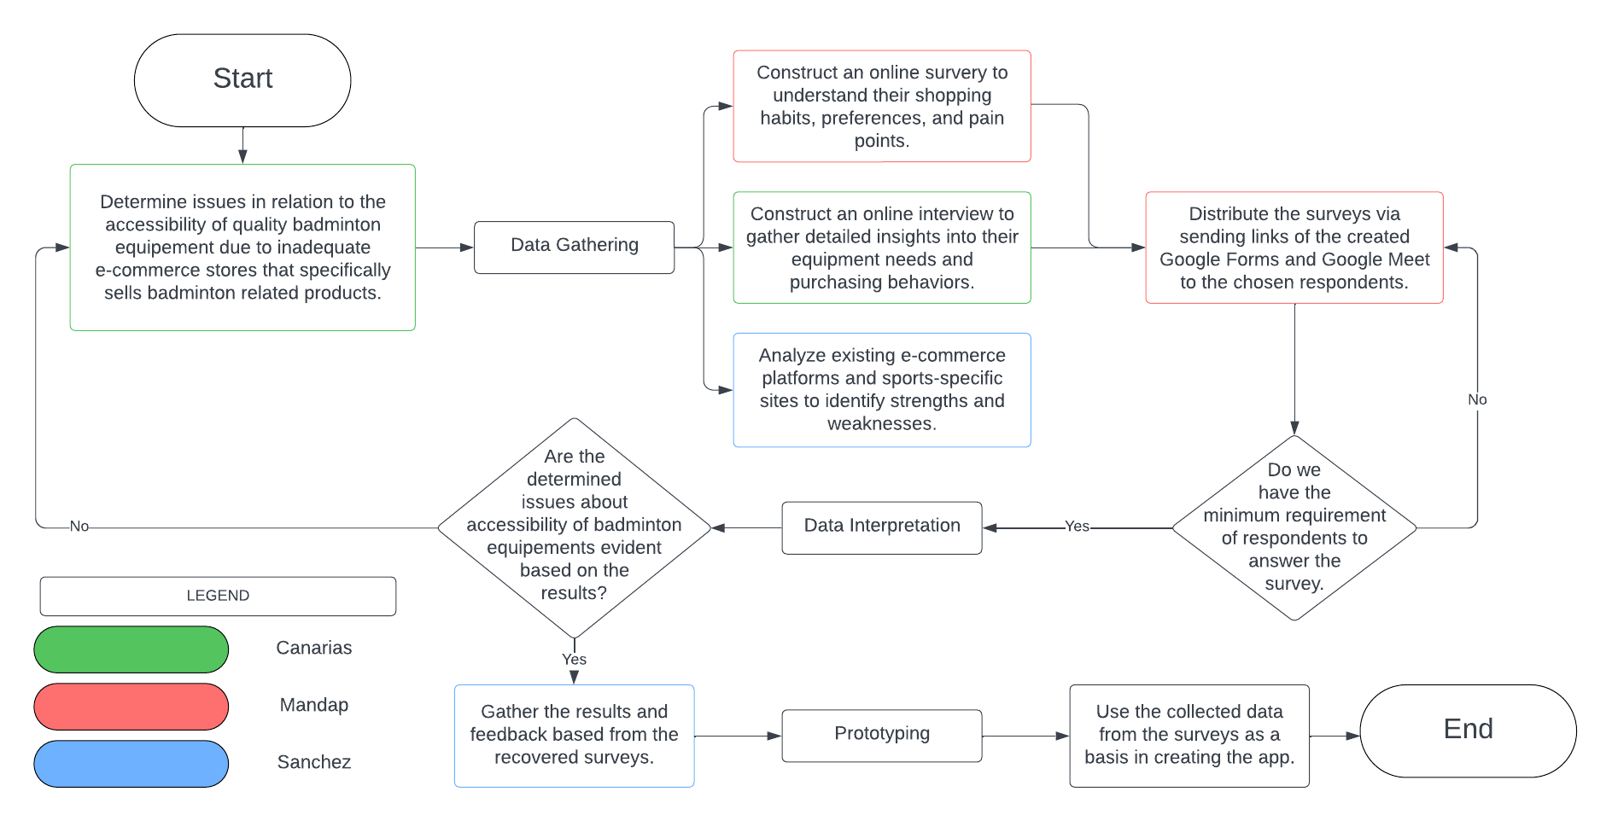

***Figure 1: Flowchart***

**References:**

*Critical factors influencing international sporting success of the Philippines: the athletes’ perspective*. (2017). Asia Pacific Journal of Sport and Social Science. <https://www.tandfonline.com/doi/abs/10.1080/21640599.2017.1323820>

Guilas, AA & Lagman, Rachel & Go, JD & Liao, LAS & Mamaril, GP & Rueca, JRQ & Tapire, KM. (2006). Incidence of Chronic Lower Extremity Musculoskeletal Injuries Among Badminton Players Participating in UAAP. Philippine Journal of Allied Health Sciences. 11. 10.36413/pjahs.0101.003.

Bueza, J. P., John, T., Hanz Martin Flores, & Teresa, M. (2023). Effectiveness of Self-Made E-Learning Videos for Dual Sports in Enhancing The Performance of Bachelor of Physical Education Students. *Education Policy and Development*, *1*(2), 53–65. https://doi.org/10.31098/epd.v1i2.1404

Zhang, Y., Duan, W., Villanueva, L. E., & Chen, S. (2023). Designing a training assistant system for badminton using artificial intelligence. *Soft Computing*, *27*(17), 12757–12768. <https://doi.org/10.1007/s00500-023-08961-9>

Cruz, A. B. (2021). Post-primary School Students’ Attitudes Toward Physical Education and Physical Activity Preferences: Philippines’ K-12 Program *the Asia-Pacific Education Researcher*, *31*(5), 507–517. <https://doi.org/10.1007/s40299-021-00598-2>

‌